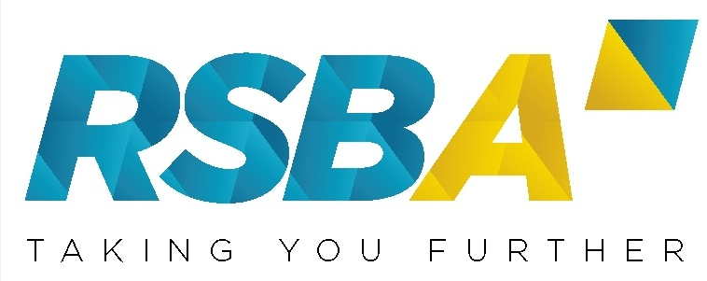

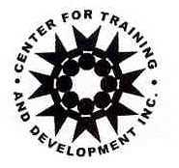

Title of Seminar : CODE OF ETHICS AND ACCOUNTING AND
REGULATORY UPDATES
Date : November 20, 2017
Time : 8:00 AM – 5:00 PM
Venue : 5th Floor, Tower 2, RCBC Plaza

Registration Form

COMPANY: _______________________________________________________________

ADDRESS: _______________________________________________________________

TEL. NO. __________________ FAX NO. _________________ EMAIL ________________

NAME OF PARTICIPANT/S: PREFERRED NAME TO
APPEAR IN NAME TAG
1.__________________________________ 1.__________________________________

2.__________________________________ 2.__________________________________

3.__________________________________ 3.__________________________________

4.__________________________________ 4.__________________________________

5.__________________________________ 5.__________________________________

Important Reminders:
- Those who confirmed but did not attend without notification on or before October 31, 2017 will be charged Php1,000.00 to cover overhead expenses. Substitution is allowed but with prior notification.
- Official receipts will be given on the day of the seminar.
- Make check payable to: Center for Training AND Development Inc or you may deposit to our account below and send us the deposit slip via fax (813-8791) or email.

Account Name: CENTER FOR TRAINING AND DEVELOPMENT INC
Account No. : 1731-0268-03
Bank’s Name : Bank of the Philippine Islands-Ayala East Branch, FGU Center
Address : 66811 Ayala Avenue, Makati City

